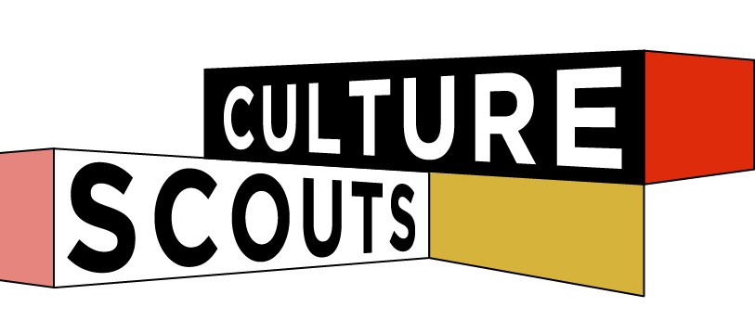

Marketing Assistant (Culture VulTure)

INtership

DESCRIPTION
An exciting opportunity to join a fast growing creative start-up! Culture Scouts Walking Tours www.culturescouts.com.au was created to provide a local view of Sydney's cultural hubs through a capsule experience blending art, food and guided conversations. For years, our team has watched a select of Sydney areas flourish to match the vim of a population left wanting for more creative and culinary destinations. In part, the tours are crafted in mind to guide both locals and international visitors amongst the bewildering heights of Sydney's diverse art and hospitality scene today. Our curated itinerary of the most interesting galleries, cafés and bars offers a snapshot takeaway of what we believe sits at the heart of the authentic Sydney lifestyle. The guided tours are also about reacquainting the public with the old cultural guards of Sydney; esoteric gems, hidden in street art alleyways and conspicuous dining locations that have thrived in shying away from modern pomp and acclaim. Our scout leaders come from patchwork backgrounds in art education and the corporate creative sectors, and are dedicated to share their expertise in a way that is both sociable and thought provoking.
We're looking for a super talented and enthusiastic intern to come onboard and take hold of our Social Media and enewsletter and make it their own.
You'll have:
- a positive attitude, we're a small team and work closely together to get our work done
- a whole lot of initiative, we want you to take this by the horns and really make it your own. The world is your oyster so to speak.
- the ability to work with little supervision, have original ideas and be ready for a challenge
- experience with mailchimp would be favourable
You also love social media, part of this role will be running with our Instagram, twitter and fb accounts. You know your hashtags from your handles.
You'll be required to come into our super office in Surry Hills 1-2 day a week (Tuesday or Wednesday depending on desk space availability) and some time (approx 3-6hours) outside of this to make sure you're on top of everything social. We send our newsletters out twice a month.
Travel costs and lunch will be covered by us for your day in the office.
To apply send us a little bit about yourself, what social media means to you and why you'd be the perfect fit for our fast paced dynamic team. This is an exciting opportunity and has the potential to lead to a full time role for the right person.

